**Logo rules**

**Clear zone**

The logotype must be positioned in its own clear space, standing apart from other images and/or text. In order to achieve this, the logotype must always  
be surrounded by a minimum clear zone which is achieved using the letter Z as shown above. The clear zone helps to protect the trademark status of the logotype, and ensures it is consistently displayed to best effect.



**Minimum sizes**

To ensure the logo is always legible, it should never be used less than 20 mm in width for the horizontal logo.

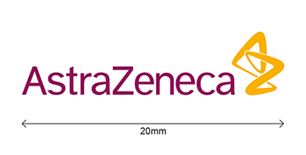

**Positive and negative logos**

Positive logos should be used on white backgrounds and light coloured images. Negative logos should be used on dark coloured images.







**Black and white logos**

Black and white logos are also available for use when printing restrictions apply.



